**Appendix**

*Study Population*

The study population included NYC residents aged 50 years and older who had at least one ambulatory care encounter from January 1, 2017 through March 6, 2020 and two or more of the following chronic conditions: arthritis, asthma, atrial fibrillation, breast cancer, colorectal cancer, lung cancer, prostate cancer, chronic kidney disease, chronic obstructive pulmonary disease, depression, diabetes, heart failure, hyperlipidemia, hypertension, ischemic heart disease, osteoporosis, and stroke. Those with a diagnosis for Alzheimer’s disease, dementia, or metastatic cancer were excluded.

*Biologically Implausible Thresholds*

Cardiovascular risk factor measurements that were biologically implausible were excluded:

* SBP <60 or >250mmHg;1
* LDL/HDL/triglyceride <10 or >900mg/dL;
* total cholesterol <10 or >1800mg/dL;2
* A1C < 3.3 or > 18.8%;3
* weight <75 or >700lbs4

**Table 1. ICD-10 Codes Used to Define Comorbidities and Exclusionary Conditions**

|  |  |
| --- | --- |
| **Condition** | **ICD-10 CM Codes** |
| Arthritis | M0500, M05011, M05012, M05019, M05021, M05022, M05029, M05031, M05032, M05039, M05041, M05042, M05049, M05051, M05052, M05059, M05061, M05062, M05069, M05071, M05072, M05079, M0509, M0510, M05111, M05112, M05119, M05121, M05122, M05129, M05131, M05132, M05139, M05141, M05142, M05149, M05151, M05152, M05159, M05161, M05162, M05169, M05171, M05172, M05179, M0519, M0520, M05211, M05212, M05219, M05221, M05222, M05229, M05231, M05232, M05239, M05241, M05242, M05249, M05251, M05252, M05259, M05261, M05262, M05269, M05271, M05272, M05279, M0529, M0530, M05311, M05312, M05319, M05321, M05322, M05329, M05331, M05332, M05339, M05341, M05342, M05349, M05351, M05352, M05359, M05361, M05362, M05369, M05371, M05372, M05379, M0539, M0540, M05411, M05412, M05419, M05421, M05422, M05429, M05431, M05432, M05439, M05441, M05442, M05449, M05451, M05452, M05459, M05461, M05462, M05469, M05471, M05472, M05479, M0549, M0550, M05511, M05512, M05519, M05521, M05522, M05529, M05531, M05532, M05539, M05541, M05542, M05549, M05551, M05552, M05559, M05561, M05562, M05569, M05571, M05572, M05579, M0559, M0560, M05611, M05612, M05619, M05621, M05622, M05629, M05631, M05632, M05639, M05641, M05642, M05649, M05651, M05652, M05659, M05661, M05662, M05669, M05671, M05672, M05679, M0569, M0570, M05711, M05712, M05719, M05721, M05722, M05729, M05731, M05732, M05739, M05741, M05742, M05749, M05751, M05752, M05759, M05761, M05762, M05769, M05771, M05772, M05779, M0579, M057A, M0580, M05811, M05812, M05819, M05821, M05822, M05829, M05831, M05832, M05839, M05841, M05842, M05849, M05851, M05852, M05859, M05861, M05862, M05869, M05871, M05872, M05879, M0589, M058A, M059, M0600, M06011, M06012, M06019, M06021, M06022, M06029, M06031, M06032, M06039, M06041, M06042, M06049, M06051, M06052, M06059, M06061, M06062, M06069, M06071, M06072, M06079, M0608, M0609, M060A, M061, M0620, M06211, M06212, M06219, M06221, M06222, M06229, M06231, M06232, M06239, M06241, M06242, M06249, M06251, M06252, M06259, M06261, M06262, M06269, M06271, M06272, M06279, M0628, M0629, M0630, M06311, M06312, M06319, M06321, M06322, M06329, M06331, M06332, M06339, M06341, M06342, M06349, M06351, M06352, M06359, M06361, M06362, M06369, M06371, M06372, M06379, M0638, M0639, M064, M0680, M06811, M06812, M06819, M06821, M06822, M06829, M06831, M06832, M06839, M06841, M06842, M06849, M06851, M06852, M06859, M06861, M06862, M06869, M06871, M06872, M06879, M0688, M0689, M068A, M069, M0800, M08011, M08012, M08019, M08021, M08022, M08029, M08031, M08032, M08039, M08041, M08042, M08049, M08051, M08052, M08059, M08061, M08062, M08069, M08071, M08072, M08079, M0808, M0809, M080A, M081, M0820, M08211, M08212, M08219, M08221, M08222, M08229, M08231, M08232, M08239, M08241, M08242, M08249, M08251, M08252, M08259, M08261, M08262, M08269, M08271, M08272, M08279, M0828, M0829, M082A, M083, M0840, M08411, M08412, M08419, M08421, M08422, M08429, M08431, M08432, M08439, M08441, M08442, M08449, M08451, M08452, M08459, M08461, M08462, M08469, M08471, M08472, M08479, M0848, M084A, M0880, M08811, M08812, M08819, M08821, M08822, M08829, M08831, M08832, M08839, M08841, M08842, M08849, M08851, M08852, M08859, M08861, M08862, M08869, M08871, M08872, M08879, M0888, M0889, M0890, M08911, M08912, M08919, M08921, M08922, M08929, M08931, M08932, M08939, M08941, M08942, M08949, M08951, M08952, M08959, M08961, M08962, M08969, M08971, M08972, M08979, M0898, M0899, M089A, M150, M151, M152, M153, M154, M158, M159, M160, M1610, M1611, M1612, M162, M1630, M1631, M1632, M164, M1650, M1651, M1652, M166, M167, M169, M170, M1710, M1711, M1712, M172, M1730, M1731, M1732, M174, M175, M179, M180, M1810, M1811, M1812, M182, M1830, M1831, M1832, M184, M1850, M1851, M1852, M189, M19011, M19012, M19019, M19021, M19022, M19029, M19031, M19032, M19039, M19041, M19042, M19049, M19071, M19072, M19079, M1909, M19111, M19112, M19119, M19121, M19122, M19129, M19131, M19132, M19139, M19141, M19142, M19149, M19171, M19172, M19179, M1919, M19211, M19212, M19219, M19221, M19222, M19229, M19231, M19232, M19239, M19241, M19242, M19249, M19271, M19272, M19279, M1929, M1990, M1991, M1992, M1993, M450, M451, M452, M453, M454, M455, M456, M457, M458, M459, M45A0, M45A1, M45A2, M45A3, M45A4, M45A5, M45A6, M45A7, M45A8, M45AB, M488X1, M488X2, M488X3, M488X4, M488X5, M488X6, M488X7, M488X8, M488X9, L4050, L4051, L4054, L4059, M4680, M4681, M4682, M4683, M4684, M4685, M4686, M4687, M4688, M4689, M4690, M4691, M4692, M4693, M4694, M4695, M4696, M4697, M4698, M4699, M47011, M47012, M47013, M47014, M47015, M47016, M47019, M47021, M47022, M47029, M4710, M4711, M4712, M4713, M4714, M4715, M4716, M4720, M4721, M4722, M4723, M4724, M4725, M4726, M4727, M4728, M47811, M47812, M47813, M47814, M47815, M47816, M47817, M47818, M47819, M47891, M47892, M47893, M47894, M47895, M47896, M47897, M47898, M47899, M479 |
| Asthma | J4520, J4521, J4522, J4530, J4531, J4532, J4540, J4541, J4542, J4550, J4551, J4552, J45901, J45902, J45909, J45990, J45991, J45998 |
| Atrial Fibrillation | I470, I471, I472, I479, I480, I481, I4811, I4819, I482, I4820, I4821, I483, I484, I4891, I4892, I491, I492, I493, I4940, I4949, I495, I498, I499 |
| Breast Cancer | C50011, C50012, C50019, C50021, C50022, C50029, C50111, C50112, C50119, C50121, C50122, C50129, C50211, C50212, C50219, C50221, C50222, C50229, C50311, C50312, C50319, C50321, C50322, C50329, C50411, C50412, C50419, C50421, C50422, C50429, C50511, C50512, C50519, C50521, C50522, C50529, C50611, C50612, C50619, C50621, C50622, C50629, C50811, C50812, C50819, C50821, C50822, C50829, C50911, C50912, C50919, C50921, C50922, C50929, D0500, D0501, D0502, D0510, D0511, D0512, D0580, D0581, D0582, D0590, D0591, D0592, Z170, Z171, Z191, Z192, Z853, Z86000 |
| Chronic Kidney Disease | D631, E0822, E0922, E1022, E1122, E1322, I120, I129, I130, I1310, I1311, I132, N181, N182, N183, N1830, N1831, N1832, N184, N185, N186, N189, R880, Z4901, Z4902, Z4931, Z4932, A1811, A5275, B520, E0821, E0829, E0921, E0929, E1021, E1029, E1121, E1129, E1321, E1329, K767, M1030, M10311, M10312, M10319, M10321, M10322, M10329, M10331, M10332, M10339, M10341, M10342, M10349, M10351, M10352, M10359, M10361, M10362, M10369, M10371, M10372, M10379, M1038, M1039, M3214, M3215, M3504, M350A, N010, N011, N012, N013, N014, N015, N016, N017, N018, N019, N01A, N020, N021, N022, N023, N024, N025, N026, N027, N028, N029, N02A, N030, N031, N032, N033, N034, N035, N036, N037, N038, N039, N03A, N040, N041, N042, N043, N044, N045, N046, N047, N048, N049, N04A, N050, N051, N052, N053, N054, N055, N056, N057, N058, N059, N05A, N060, N061, N062, N063, N064, N065, N066, N067, N068, N069, N06A, N070, N071, N072, N073, N074, N075, N076, N077, N078, N079, N07A, N08, N140, N141, N142, N143, N144, N150, N158, N159, N16, N251, N2589, N259, N261, N269, N990, Q6102, Q6111, Q6119, Q612, Q613, Q614, Q615, Q618 |
| Colorectal Cancer | C180, C181, C182, C183, C184, C185, C186, C187, C188, C189, C19, C20, C260, C49A4, C49A5, D010, D011, D012, D0140, Z85030, Z85038, Z85040, Z85048 |
| COPD | J410, J411, J418, J42, J430, J431, J432, J438, J439, J440, J441, J449, J470, J471, J479, J40, J982, J983 |
| Depression | F0631, F0632, F0634, F320, F321, F322, F323, F324, F328, F3281, F3289, F329, F32A, F330, F331, F332, F333, F3341, F338, F339, F341, F310, F3110, F3111, F3112, F3113, F312, F3130, F3131, F3132, F314, F315, F3160, F3161, F3162, F3163, F3164, F3171, F3173, F3175, F3176, F3177, F3178, F3181, F3189, F319, F325, F3340, F3342, F340, F4321, F4323 |
| Diabetes | E0800, E0801, E0810, E0811, E0821, E0822, E0829, E08311, E08319, E08321, E083211, E083212, E083213, E083219, E08329, E083291, E083292, E083293, E083299, E08331, E083311, E083312, E083313, E083319, E08339, E083391, E083392, E083393, E083399, E08341, E083411, E083412, E083413, E083419, E08349, E083491, E083492, E083493, E083499, E08351, E083511, E083512, E083513, E083519, E083521, E083522, E083523, E083529, E083531, E083532, E083533, E083539, E083541, E083542, E083543, E083549, E083551, E083552, E083553, E083559, E08359, E083591, E083592, E083593, E083599, E0836, E0837X1, E0837X2, E0837X3, E0837X9, E0839, E0840, E0841, E0842, E0843, E0844, E0849, E0851, E0852, E0859, E08610, E08618, E08620, E08621, E08622, E08628, E08630, E08638, E08641, E08649, E0865, E0869, E088, E089, E0900, E0901, E0910, E0911, E0921, E0922, E0929, E09311, E09319, E09321, E093211, E093212, E093213, E093219, E09329, E093291, E093292, E093293, E093299, E09331, E093311, E093312, E093313, E093319, E09339, E093391, E093392, E093393, E093399, E09341, E093411, E093412, E093413, E093419, E09349, E093491, E093492, E093493, E093499, E09351, E093511, E093512, E093513, E093519, E093521, E093522, E093523, E093529, E093531, E093532, E093533, E093539, E093541, E093542, E093543, E093549, E093551, E093552, E093553, E093559, E09359, E093591, E093592, E093593, E093599, E0936, E0937X1, E0937X2, E0937X3, E0937X9, E0939, E0940, E0941, E0942, E0943, E0944, E0949, E0951, E0952, E0959, E09610, E09618, E09620, E09621, E09622, E09628, E09630, E09638, E09641, E09649, E0965, E0969, E098, E099, E1010, E1011, E1021, E1022, E1029, E10311, E10319, E10321, E103211, E103212, E103213, E103219, E10329, E103291, E103292, E103293, E103299, E10331, E103311, E103312, E103313, E103319, E10339, E103391, E103392, E103393, E103399, E10341, E103411, E103412, E103413, E103419, E10349, E103491, E103492, E103493, E103499, E10351, E103511, E103512, E103513, E103519, E103521, E103522, E103523, E103529, E103531, E103532, E103533, E103539, E103541, E103542, E103543, E103549, E103551, E103552, E103553, E103559, E10359, E103591, E103592, E103593, E103599, E1036, E1037X1, E1037X2, E1037X3, E1037X9, E1039, E1040, E1041, E1042, E1043, E1044, E1049, E1051, E1052, E1059, E10610, E10618, E10620, E10621, E10622, E10628, E10630, E10638, E10641, E10649, E1065, E1069, E108, E109, E1100, E1101, E1110, E1111, E1121, E1122, E1129, E11311, E11319, E11321, E113211, E113212, E113213, E113219, E11329, E113291, E113292, E113293, E113299, E11331, E113311, E113312, E113313, E113319, E11339, E113391, E113392, E113393, E113399, E11341, E113411, E113412, E113413, E113419, E11349, E113491, E113492, E113493, E113499, E11351, E113511, E113512, E113513, E113519, E113521, E113522, E113523, E113529, E113531, E113532, E113533, E113539, E113541, E113542, E113543, E113549, E113551, E113552, E113553, E113559, E11359, E113591, E113592, E113593, E113599, E1136, E1137X1, E1137X2, E1137X3, E1137X9, E1139, E1140, E1141, E1142, E1143, E1144, E1149, E1151, E1152, E1159, E11610, E11618, E11620, E11621, E11622, E11628, E11630, E11638, E11641, E11649, E1165, E1169, E118, E119, E1300, E1301, E1310, E1311, E1321, E1322, E1329, E13311, E13319, E13321, E133211, E133212, E133213, E133219, E13329, E133291, E133292, E133293, E133299, E13331, E133311, E133312, E133313, E133319, E13339, E133391, E133392, E133393, E133399, E13341, E133411, E133412, E133413, E133419, E13349, E133491, E133492, E133493, E133499, E13351, E133511, E133512, E133513, E133519, E133521, E133522, E133523, E133529, E133531, E133532, E133533, E133539, E133541, E133542, E133543, E133549, E133551, E133552, E133553, E133559, E13359, E133591, E133592, E133593, E133599, E1336, E1337X1, E1337X2, E1337X3, E1337X9, E1339, E1340, E1341, E1342, E1343, E1344, E1349, E1351, E1352, E1359, E13610, E13618, E13620, E13621, E13622, E13628, E13630, E13638, E13641, E13649, E1365, E1369, E138, E139, E891, O24011, O24012, O24013, O24019, O2402, O2403, O24111, O24112, O24113, O24119, O2412, O2413, O24311, O24312, O24313, O24319, O2432, O2433, O24410, O24414, O24415, O24419, O24420, O24424, O24425, O24429, O24430, O24434, O24435, O24439, O24811, O24812, O24813, O24819, O2482, O2483, O24911, O24912, O24913, O24919, O2492, O2493, O99810, O99814, O99815 |
| Heart Failure | I0981, I110, I130, I132, I501, I5020, I5021, I5022, I5023, I5030, I5031, I5032, I5033, I5040, I5041, I5042, I5043, I50810, I50811, I50812, I50813, I50814, I5082, I5083, I5084, I5089, I509, I97130, I97131, O29121, O29122, O29123, O29129, Z95811, Z95812, I420, I425, I426, I427, I428, I43, P290 |
| Hyperlipidemia | E780, E7800, E7801, E781, E782, E783, E784, E7841, E7849, E785 |
| Hypertension | H35031, H35032, H35033, I10, I110, I119, I120, I129, I130, I1310, I1311, I132, I150, I151, I152, I158, I159, I160, I161, I169, I674, I868, I87001, I87002, I87003, I87009, I87011, I87012, I87013, I87019, I87021, I87022, I87023, I87029, I87031, I87032, I87033, I87039, I87091, I87092, I87093, I87099, I871, I872, I87301, I87302, I87303, I87309, I87311, I87312, I87313, I87319, I87321, I87322, I87323, I87329, I87331, I87332, I87333, I87339, I87391, I87392, I87393, I87399, I973, O10011, O10012, O10013, O10019, O1002, O1003, O10111, O10112, O10113, O10119, O1012, O1013, O10211, O10212, O10213, O10219, O1022, O1023, O10311, O10312, O10313, O10319, O1032, O1033, O10411, O10412, O10413, O10419, O1042, O1043, O10911, O10912, O10913, O10919, O1092, O1093, O111, O112, O113, O114, O115, O119, O131, O132, O133, O134, O135, O139, O161, O162, O163, O164, O165, O169, H35039, N262 |
| Ischemic Heart Disease | I200, I201, I208, I209, I240, I248, I249, I2510, I25110, I25111, I25118, I25119, I252, I255, I256, I25700, I25701, I25708, I25709, I25710, I25711, I25718, I25719, I25720, I25721, I25728, I25729, I25730, I25731, I25738, I25739, I25750, I25751, I25758, I25759, I25760, I25761, I25768, I25769, I25790, I25791, I25798, I25799, I25810, I25811, I25812, I2582, I2583, I2584, I2589, I259, Z951, Z955, Z9861, I241, I253, I2541, I2542 |
| Lung Cancer | C33, C3400, C3401, C3402, C3410, C3411, C3412, C342, C3430, C3431, C3432, C3480, C3481, C3482, C3490, C3491, C3492, C384, C390, C399, D021, D0220, D0221, D0222, D023, D024, Z85110, Z85118 |
| Osteoporosis | M8000XA, M80011A, M80012A, M80019A, M80021A, M80022A, M80029A, M80031A, M80032A, M80039A, M80041A, M80042A, M80049A, M80051A, M80052A, M80059A, M80061A, M80062A, M80069A, M80071A, M80072A, M80079A, M8008XA, M800AXA, M8080XA, M80811A, M80812A, M80819A, M80821A, M80822A, M80829A, M80831A, M80832A, M80839A, M80841A, M80842A, M80849A, M80851A, M80852A, M80859A, M80861A, M80862A, M80869A, M80871A, M80872A, M80879A, M8088XA, M808AXA, M810, M816, M818 |
| Prostate Cancer | C61, D075, Z8546 |
| Stroke | I6000, I6001, I6002, I6010, I6011, I6012, I602, I6020, I6021, I6022, I6030, I6031, I6032, I604, I6050, I6051, I6052, I606, I607, I608, I609, I610, I611, I612, I613, I614, I615, I616, I618, I619, I6200, I6201, I6202, I6203, I621, I629, G450, G451, G452, G453, G458, G459, G460, G461, G462, G463, G464, G465, G466, G467, G468, G9731, G9732, I6300, I63011, I63012, I63013, I63019, I6302, I63031, I63032, I63033, I63039, I6309, I6310, I63111, I63112, I63113, I63119, I6312, I63131, I63132, I63133, I63139, I6319, I6320, I63211, I63212, I63213, I63219, I6322, I63231, I63232, I63233, I63239, I6329, I6330, I63311, I63312, I63313, I63319, I63321, I63322, I63323, I63329, I63331, I63332, I63333, I63339, I63341, I63342, I63343, I63349, I6339, I6340, I63411, I63412, I63413, I63419, I63421, I63422, I63423, I63429, I63431, I63432, I63433, I63439, I63441, I63442, I63443, I63449, I6349, I6350, I63511, I63512, I63513, I63519, I63521, I63522, I63523, I63529, I63531, I63532, I63533, I63539, I63541, I63542, I63543, I63549, I6359, I636, I638, I6381, I6389, I639, I67841, I67848, I6789, I97810, I97811, I97820, I97821 |
| Alzheimer’s Disease | G300, G301, G308, G309 |
| Dementia | F0150, F0151, F0280, F0281, F0390, F0391, F05, G138, G3101, G3109, G311, G312, G3183, G94, R4181 |
| Metastatic Cancer | C770, C771, C772, C773, C774, C775, C778, C779, C7800, C7801, C7802, C781, C782, C7830, C7839, C784, C785, C786, C787, C7880, C7889, C7900, C7901, C7902, C7910, C7911, C7919, C792, C7931, C7932, C7940, C7949, C7951, C7952, C7960, C7961, C7962, C7970, C7971, C7972, C7981, C7982, C7989, C799 |

**Table 2. Demographic Characteristics and Comorbidity Prevalence among NYC Residents Aged 50 and Older with Multiple Chronic Conditions Receiving Care at NYC INSIGHT Facilities, September 2019-March 2020**

|  |  |
| --- | --- |
|  | **N** |
| **Age** |  |
| 50-64 | 132,919 (36.13%) |
| 65+ | 234,982 (63.87%) |
| **Poverty Levela** |  |
| Low | 87,626 (23.82%) |
| Medium | 159,113 (43.25%) |
| High | 72,682 (19.76%) |
| Very High | 48,423 (13.16%) |
| Unknown | 57 (0.02%) |
| **Comorbidities** | **Prevalence (95% CI)** |
| Acute Myocardial Infarction | 4.0 (3.9-4.1) |
| Arthritis | 41.8 (41.6-41.9) |
| Asthma | 15.5 (15.4-15.6) |
| Atrial Fibrillation | 18.4 (18.3-18.5) |
| Breast Cancer | 5.7 (5.7-5.8) |
| Chronic Kidney Disease | 17.5 (17.4-17.6) |
| Colorectal Cancer | 1.6 (1.6-1.7) |
| COPD | 14.5 (14.4-14.6) |
| Depression | 17.1 (17.0-17.3) |
| Diabetes | 37.1 (37.0-37.3) |
| Heart Failure | 11.4 (11.3-11.5) |
| Hyperlipidemia | 72.1 (72.0-72.3) |
| Hypertension | 79.3 (79.1-79.4) |
| Ischemic Heart Disease | 28.2 (28.0-28.3) |
| Lung Cancer | 1.1 (1.1-1.2) |
| Osteoporosis | 13.4 (13.3-13.5) |
| Prostate Cancer | 3.7 (3.6-3.8) |
| Stroke | 7.3 (7.2-7.4) |
|  | **367,901** |

aPoverty level: low: <10% of Zip Code Tabulation Area [ZCTA] residents living below the Federal Poverty Level (FPL), medium: 10 to <20%, high: 20 to <30%, and very high: ≥30%.

**Table 3. Age-Adjusted Odds Ratios for Comorbidity Prevalence among NYC Residents Aged 50 and Older with Multiple Chronic Conditions Receiving Care at NYC INSIGHT Facilities, September 2019-March 2020**

|  |  |  |  |  |  |  |  |  |  |  |  |  |  |  |  |
| --- | --- | --- | --- | --- | --- | --- | --- | --- | --- | --- | --- | --- | --- | --- | --- |
|  | | **Asian – Female** | | **Asian – Male** | | **Black – Female** | | **Black - Male** | | **Latino - Female** | | **Latino - Male** | | **White - Female** | |
| Acute Myocardial Infarction | | 0.52 (0.46-0.6) | | 1.31 (1.18-1.46) | | 0.46 (0.43-0.49) | | 0.87 (0.81-0.94) | | 0.49 (0.46-0.53) | | 1.02 (0.96-1.08) | | 0.52 (0.49-0.55) | |
| Arthritis | | 1.26 (1.2-1.33) | | 0.61 (0.57-0.65) | | 1.84 (1.79-1.89) | | 0.89 (0.86-0.92) | | 1.78 (1.74-1.83) | | 0.79 (0.77-0.82) | | 1.73 (1.7-1.77) | |
| Asthma | | 1.35 (1.25-1.46) | | 0.88 (0.8-0.98) | | 2.39 (2.31-2.48) | | 1.18 (1.12-1.25) | | 3.33 (3.23-3.44) | | 1.4 (1.34-1.46) | | 1.56 (1.51-1.61) | |
| Atrial Fibrillation | | 0.45 (0.42-0.49) | | 0.72 (0.67-0.77) | | 0.4 (0.39-0.42) | | 0.64 (0.61-0.67) | | 0.38 (0.37-0.39) | | 0.63 (0.61-0.66) | | 0.6 (0.59-0.62) | |
| Breast Cancer | | 0.8 (0.74-0.87) | | -- | | 0.63 (0.6-0.66) | | -- | | 0.57 (0.54-0.59) | | -- | | (Referent) | |
| Chronic Kidney Disease | | 0.94 (0.88-1.01) | | 1.93 (1.8-2.06) | | 1.81 (1.75-1.88) | | 3.19 (3.07-3.32) | | 1.23 (1.19-1.27) | | 2.2 (2.13-2.28) | | 0.49 (0.47-0.5) | |
| Colorectal Cancer | | 0.74 (0.6-0.91) | | 1.14 (0.94-1.39) | | 0.86 (0.77-0.95) | | 1.06 (0.93-1.2) | | 0.79 (0.72-0.87) | | 1.08 (0.97-1.2) | | 0.85 (0.78-0.92) | |
| COPD | | 0.58 (0.53-0.63) | | 0.88 (0.81-0.95) | | 0.88 (0.84-0.91) | | 0.9 (0.86-0.95) | | 0.88 (0.85-0.91) | | 0.84 (0.8-0.87) | | 1.03 (1.0-1.06) | |
| Depression | | 0.6 (0.55-0.65) | | 0.38 (0.34-0.43) | | 1.09 (1.05-1.13) | | 0.76 (0.72-0.8) | | 2.51 (2.43-2.59) | | 1.19 (1.14-1.23) | | 1.61 (1.57-1.66) | |
| Diabetes | | 1.65 (1.56-1.73) | | 2.53 (2.4-2.68) | | 2.03 (1.98-2.09) | | 2.36 (2.28-2.44) | | 1.98 (1.93-2.03) | | 2.52 (2.44-2.59) | | 0.66 (0.64-0.68) | |
| Heart Failure | | 0.57 (0.52-0.63) | | 1.06 (0.97-1.15) | | 0.97 (0.94-1.02) | | 1.68 (1.6-1.76) | | 0.87 (0.84-0.91) | | 1.6 (1.53-1.66) | | 0.56 (0.54-0.58) | |
| Hyperlipidemia | | 0.73 (0.69-0.77) | | 1.04 (0.97-1.11) | | 0.52 (0.51-0.54) | | 0.56 (0.54-0.59) | | 0.64 (0.62-0.66) | | 0.8 (0.77-0.83) | | 0.71 (0.69-0.72) | |
| Hypertension | | 0.87 (0.82-0.92) | | 1.51 (1.4-1.62) | | 2.26 (2.18-2.35) | | 2.45 (2.33-2.57) | | 1.34 (1.3-1.38) | | 1.97 (1.89-2.05) | | 0.56 (0.54-0.58) | |
| Ischemic Heart Disease | | 0.35 (0.33-0.37) | | 1.11 (1.05-1.18) | | 0.33 (0.32-0.34) | | 0.55 (0.53-0.58) | | 0.39 (0.38-0.4) | | 0.78 (0.75-0.8) | | 0.37 (0.36-0.38) | |
| Lung Cancer | | 1.35 (1.11-1.64) | | 1.62 (1.32-1.98) | | 0.7 (0.61-0.8) | | 0.69 (0.57-0.82) | | 0.58 (0.51-0.66) | | 0.59 (0.51-0.7) | | 1.25 (1.15-1.36) | |
| Osteoporosis | | 10.5 (9.76-11.2) | | 0.84 (0.72-0.99) | | 3.64 (3.45-3.84) | | 0.59 (0.53-0.67) | | 7.25 (6.92-7.61) | | 0.77 (0.7-0.84) | | 9.72 (9.3-10.16) | |
| Prostate Cancer | | -- | | 0.51 (0.44-0.58) | | -- | | 2.19 (2.08-2.3) | | -- | | 1.08 (1.03-1.14) | | -- | |
| Stroke | | 0.92 (0.83-1.01) | | 1.23 (1.12-1.36) | | 1.03 (0.98-1.09) | | 1.28 (1.21-1.36) | | 0.94 (0.9-0.98) | | 1.19 (1.13-1.25) | | 0.83 (0.8-0.87) | |

1Odds ratios estimated using logistic regression analyses controlling for 5-year age group with White – Male as the referent group for all conditions except breast cancer. Logistic regression model for breast cancer was limited to females only, with White – Female as the referent group.

**Figure 1. Leading Comorbidity Profiles among NYC Residents Aged 50 and Older with Multiple Chronic Conditions Receiving Care at NYC INSIGHT Facilities, September 2019-March 2020 – Asian Female 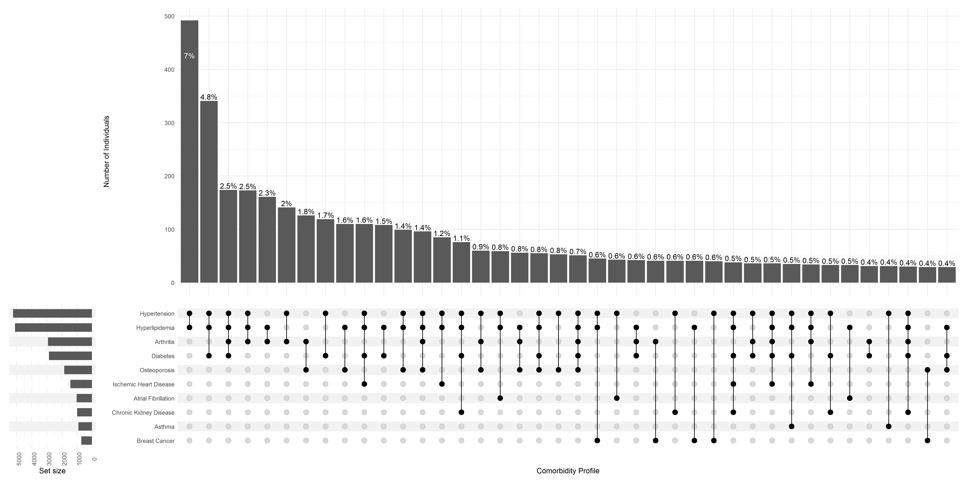 Figure 2. Leading Comorbidity Profiles among NYC Residents Aged 50 and Older with Multiple Chronic Conditions Receiving Care at NYC INSIGHT Facilities, September 2019-March 2020 – Asian Male 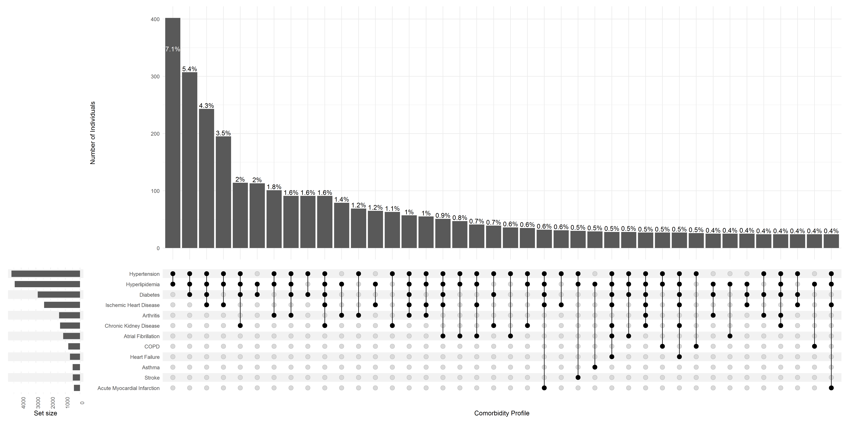 Figure 3. Leading Comorbidity Profiles among NYC Residents Aged 50 and Older with Multiple Chronic Conditions Receiving Care at NYC INSIGHT Facilities, September 2019-March 2020 – Black Female 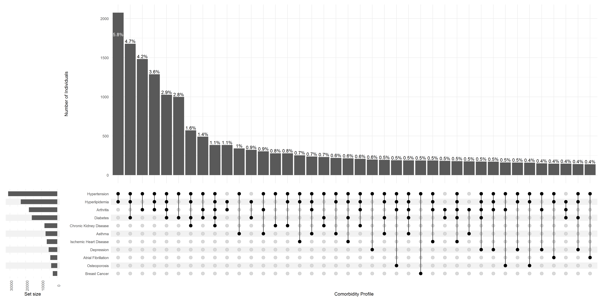 Figure 4. Leading Comorbidity Profiles among NYC Residents Aged 50 and Older with Multiple Chronic Conditions Receiving Care at NYC INSIGHT Facilities, September 2019-March 2020 – Black Male 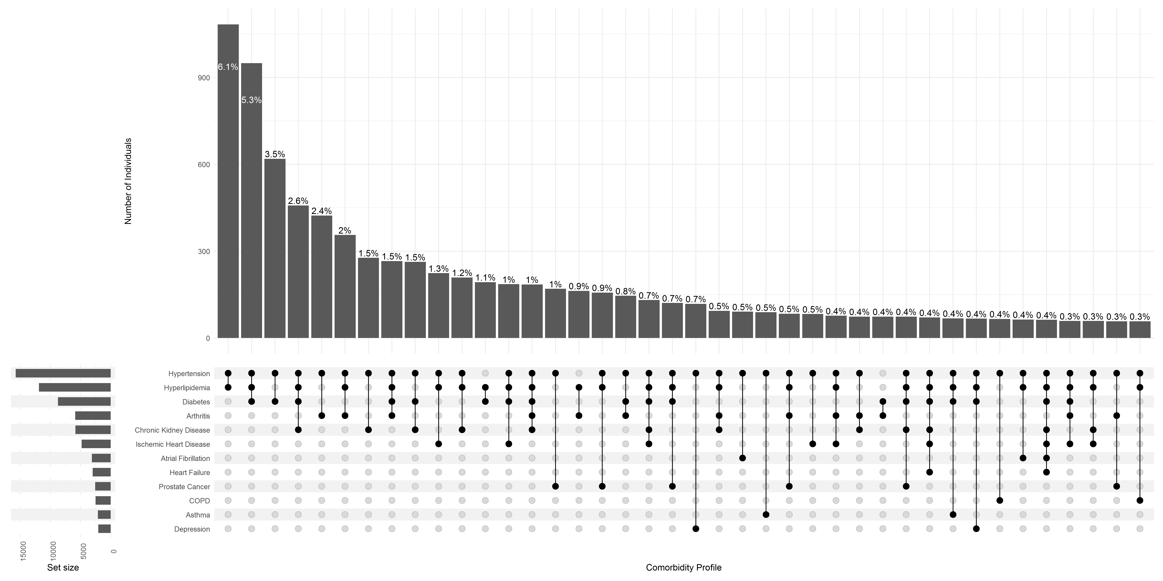 Figure 5. Leading Comorbidity Profiles among NYC Residents Aged 50 and Older with Multiple Chronic Conditions Receiving Care at NYC INSIGHT Facilities, September 2019-March 2020 – Hispanic/Latino Female 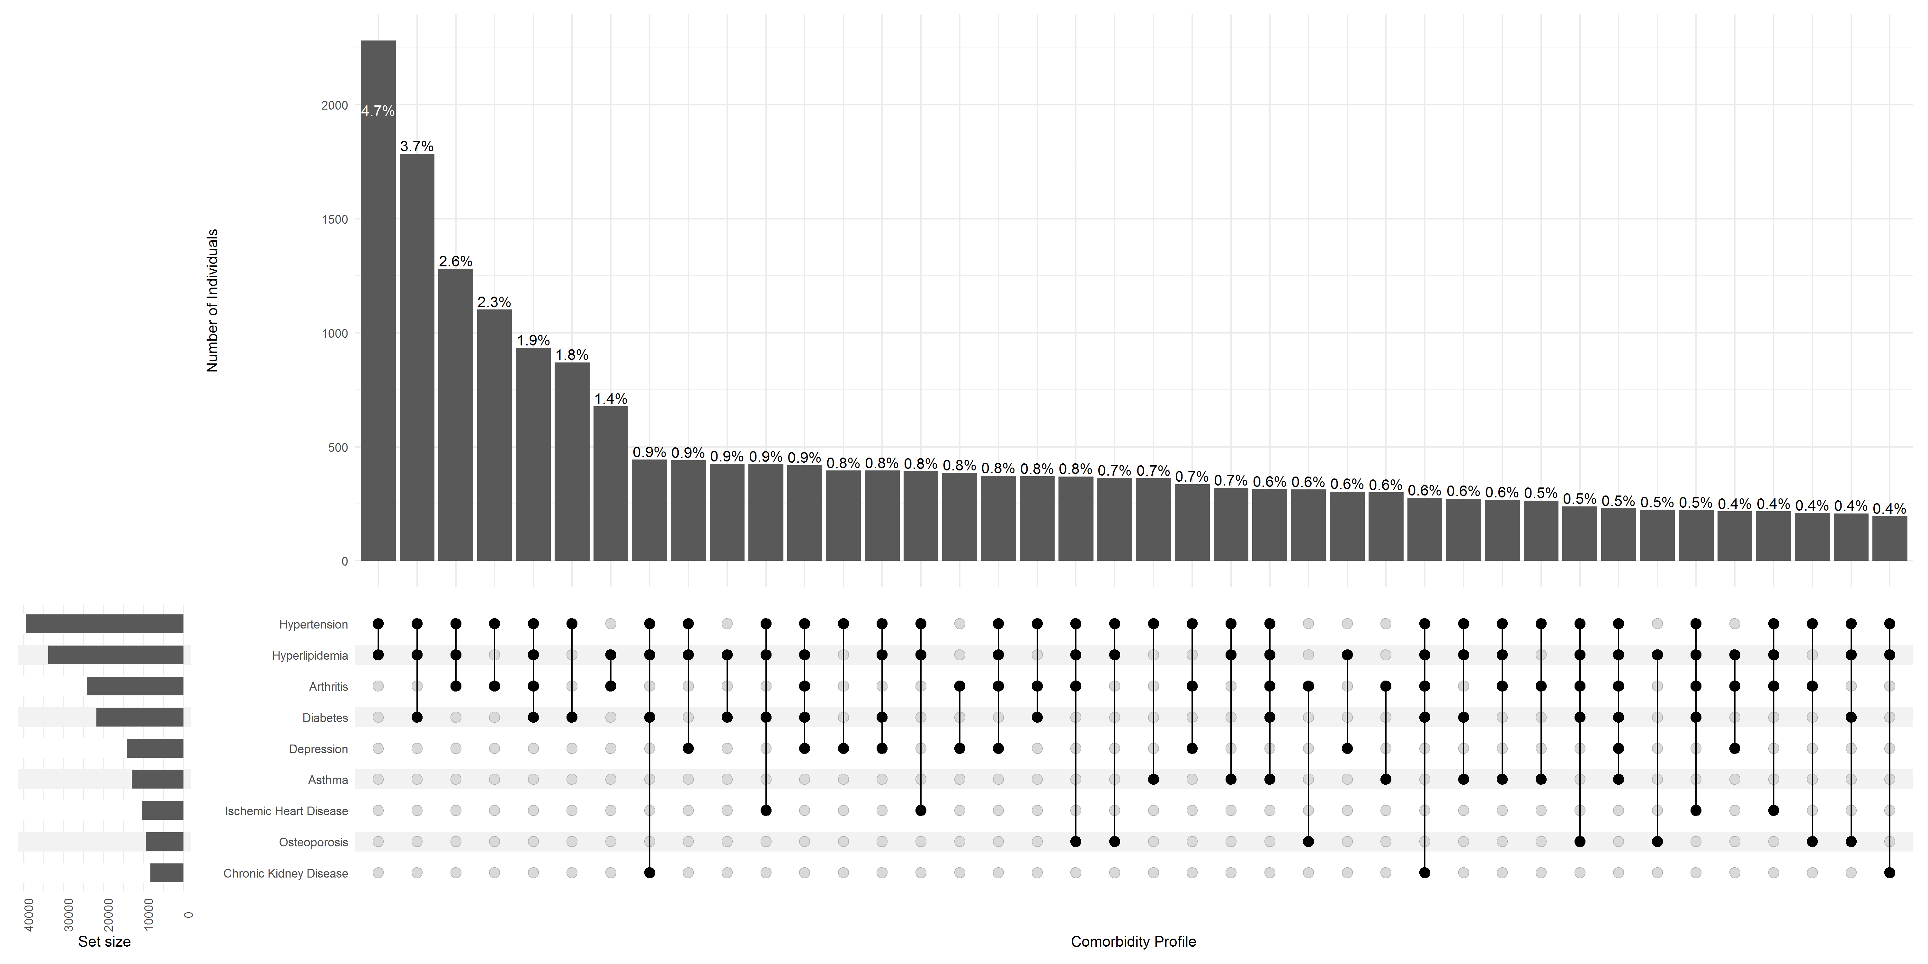 Figure 6. Leading Comorbidity Profiles among NYC Residents Aged 50 and Older with Multiple Chronic Conditions Receiving Care at NYC INSIGHT Facilities, September 2019-March 2020 – Hispanic/Latino Male 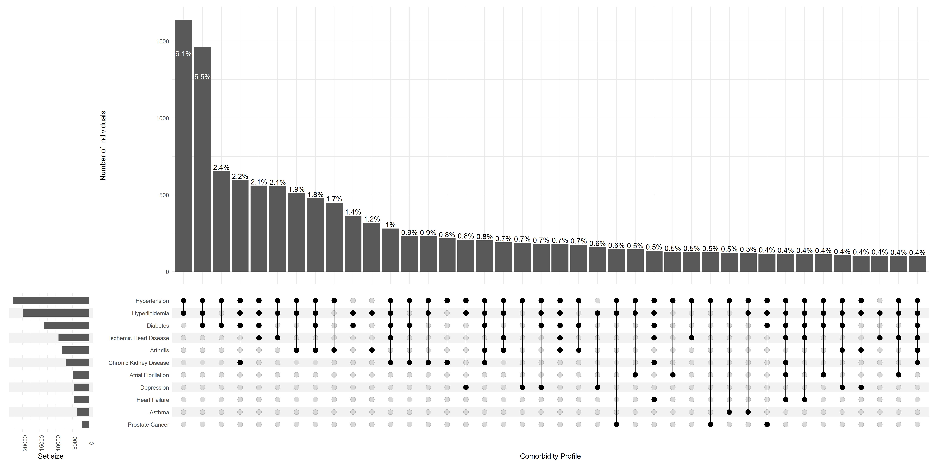 Figure 7. Leading Comorbidity Profiles among NYC Residents Aged 50 and Older with Multiple Chronic Conditions Receiving Care at NYC INSIGHT Facilities, September 2019-March 2020 – White Female 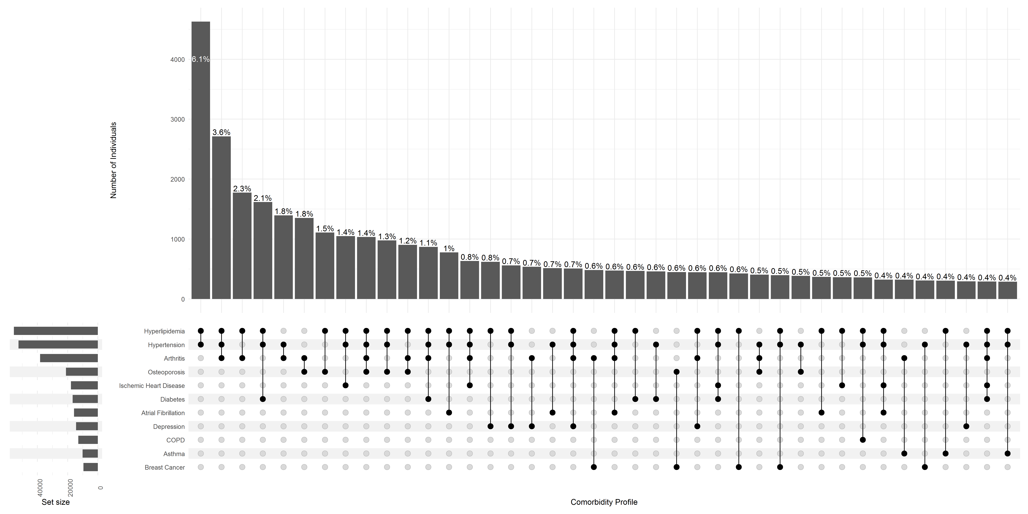 Figure 8. Leading Comorbidity Profiles among NYC Residents Aged 50 and Older with Multiple Chronic Conditions Receiving Care at NYC INSIGHT Facilities, September 2019-March 2020 – White Male 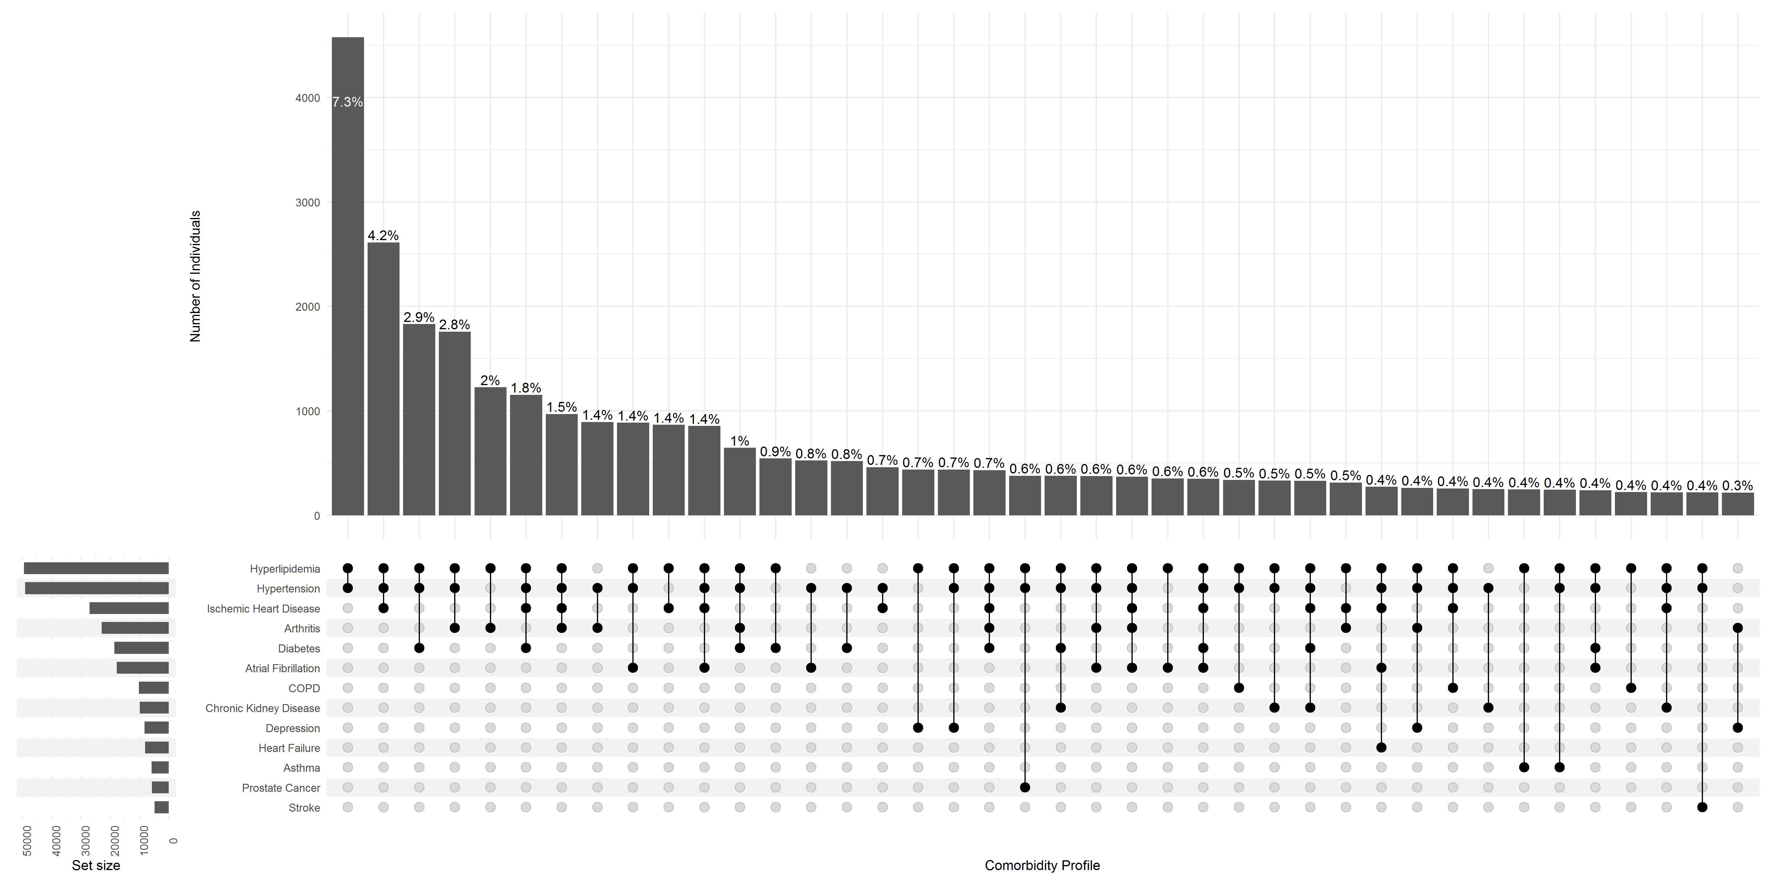 Figure 9. Leading Comorbidity Profiles by Sex and Race/Ethnicity among NYC Residents Aged 50 and Older with Multiple Chronic Conditions Receiving Care at NYC INSIGHT Facilities, September 2019-March 2020** 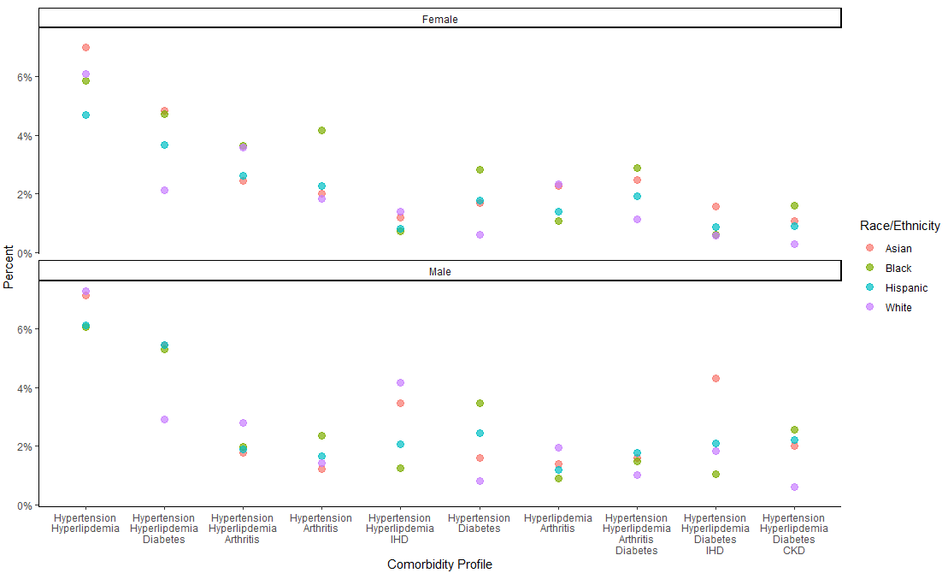

**References**

1. Cheng FW, Gao X, Mitchell DC, et al. Body mass index and all-cause mortality among older adults. 2016;24(10):2232-2239. doi:<https://doi.org/10.1002/oby.21612>

2. Health Data Research UK. HDRUK Phenotype Library. August 22, 2023. Accessed August 22, 2023. <https://phenotypes.healthdatagateway.org/>

3. Wang P. What Clinical Laboratorians Should Do in Response to Extremely Low Hemoglobin A1c Results. *Lab Med*. Feb 2017;48(1):89-92. doi:10.1093/labmed/lmw050

4. Funderburk JS, Kenneson A, Maisto SA. Identifying Classes of Veterans With Multiple Risk Factors. *Mil Med*. 2014;179(10):1119-1126. doi:10.7205/MILMED-D-14-00119 %J Military Medicine